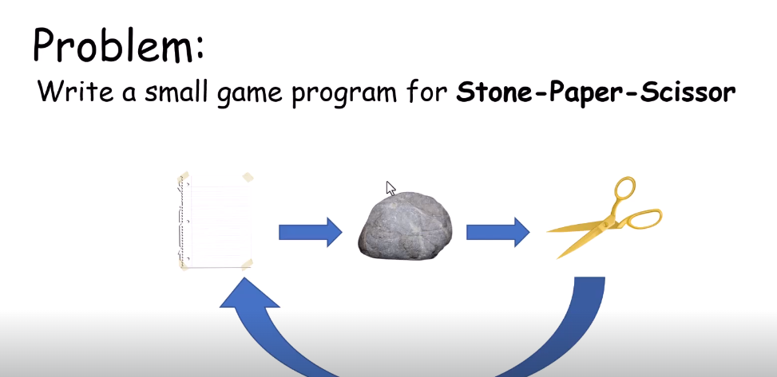

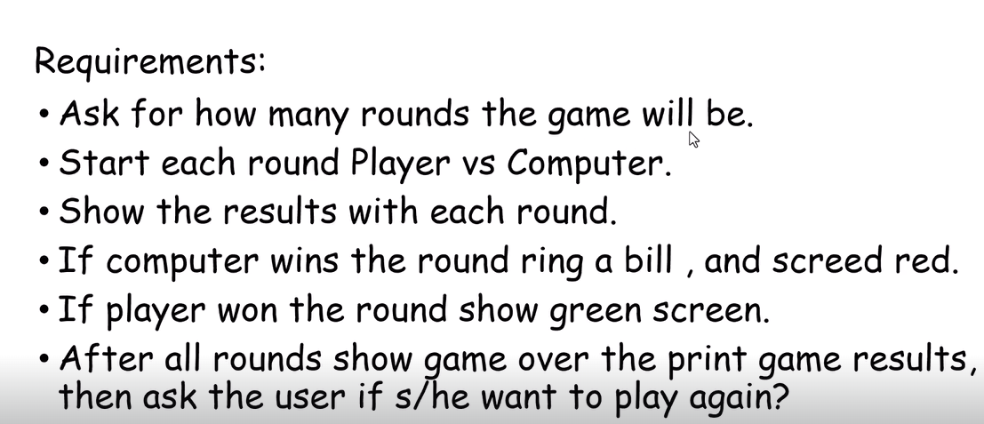

This Is A Simple Game For C++ Basic Concepts

You Are Facing The PC

Game Rules:

-Paper Defeats Stone

-Stone Defeats Scissors

-Scissors Defeats Papper